Calculus 2 Lecture 9.1: Convergence and Divergence of Sequences
What are sequences?

A sequence 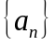 is a set of terms

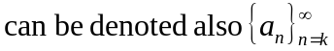 If not shown, n=1 to start sequence is assumed.

Example
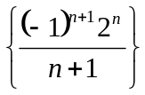
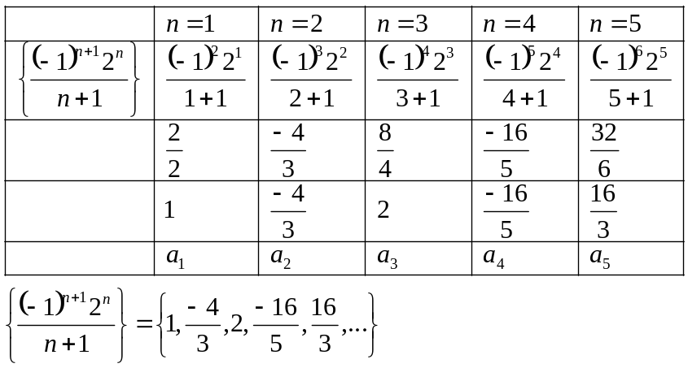

Example
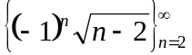
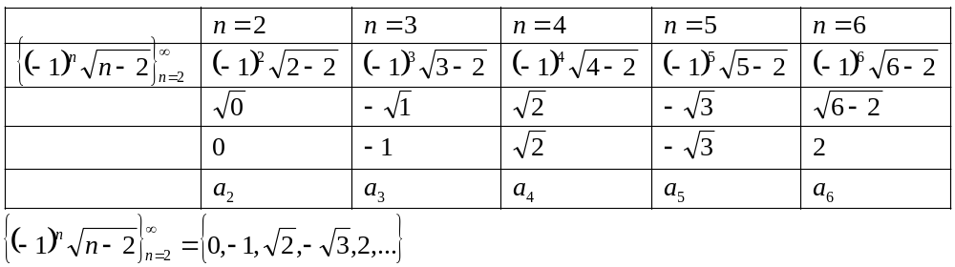

Example
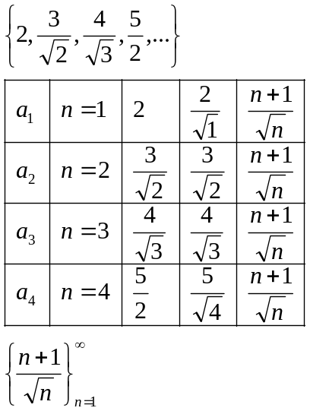

Example
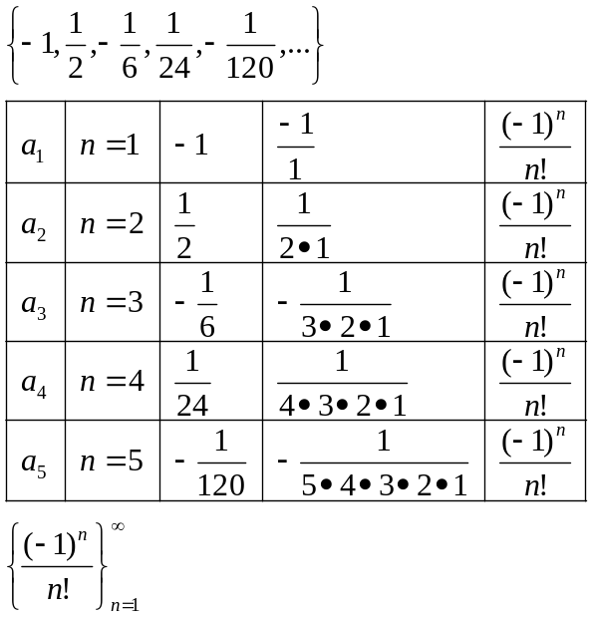

Example
This is a Recursive sequence.
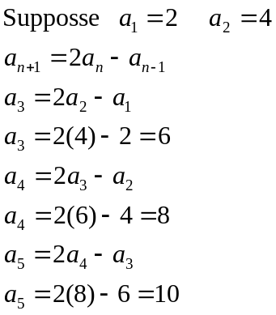

Limits: A sequence 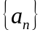 has a limit 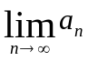 (convergent or divergent test)
If the limit of “a” sequence exists then the sequence converges.
If the limit of “a” sequence does not exist(or goes to 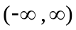 then the sequence diverges.

Properties:
- 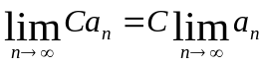
- 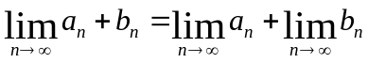
- 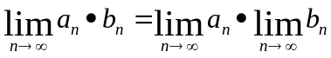
- 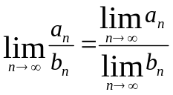
- 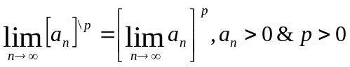

Example
Show convergence or divergence.
- 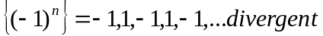
- 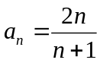
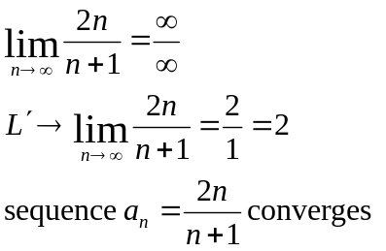

- 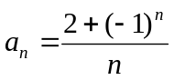
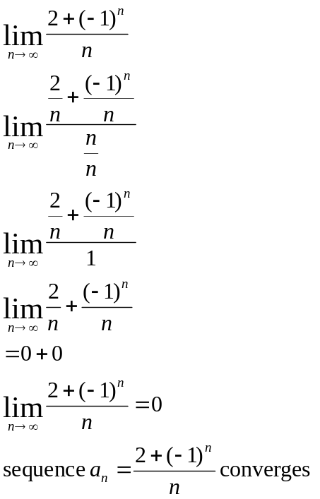

Example
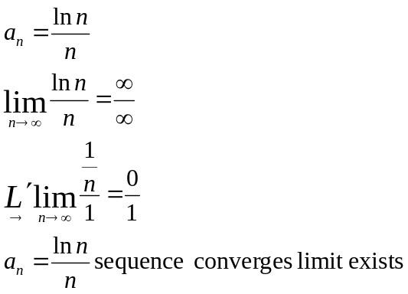

Example
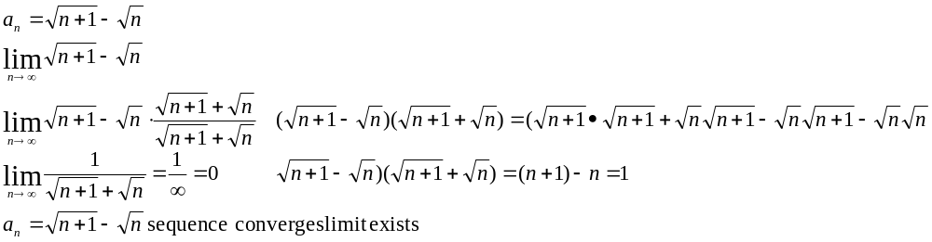

Squeeze Theorem
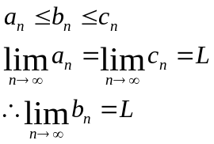

Example
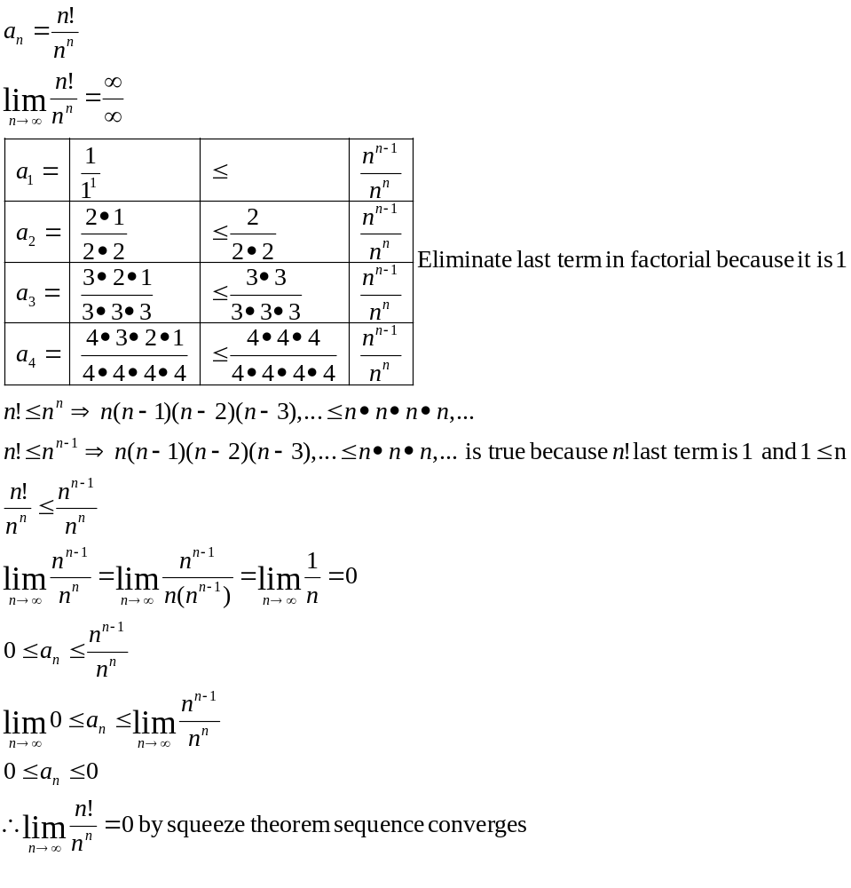
NOTE
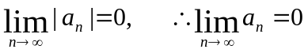

Example
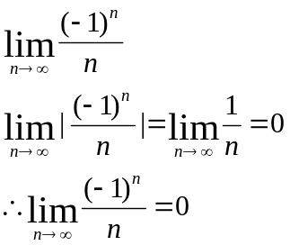

NOTE
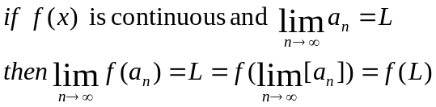

Example
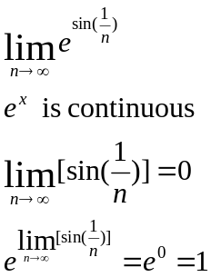
Example
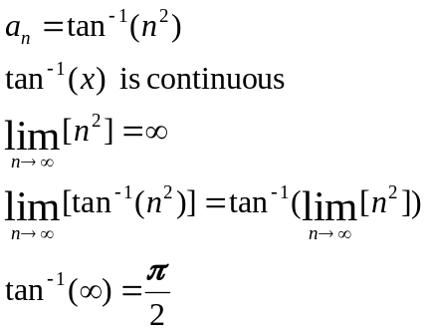

Monotonic Sequences
Sequences terms always go larger or always go smaller.
A Sequence that is always increasing or always decreasing.

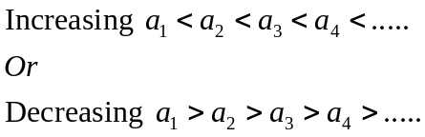

Example
Show 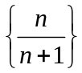 is increasing

Next term from is 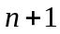 therefore next term will be 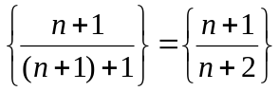
Prove that 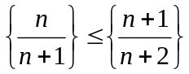 is true.

Multiply inequality by 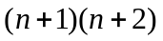since n>0 do not need to worry about changing direction of inequality. Not negative.

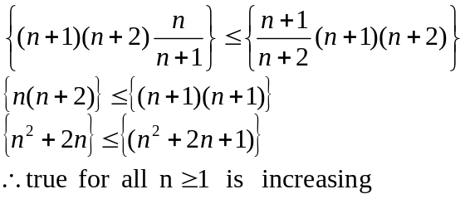

Using a function to represent a sequence and use the first derivative test to determine if the sequence is increasing of decreasing, evaluate
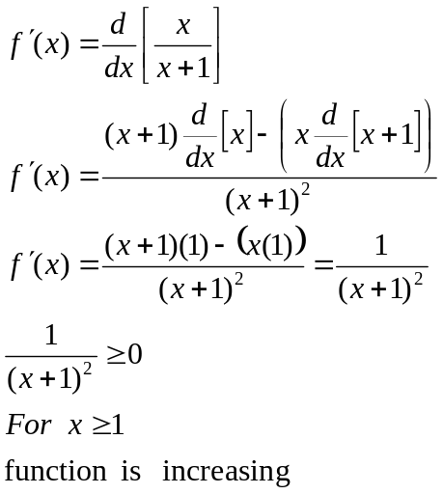

Take the first derivative test see note here

..\Calculus 1\ProfessorLeonard_Calculus_1_Lecture_3_3_The First Derivative Test for Increasing and Decreasing.doc

Example
Is sequence increasing or decreasing?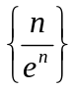
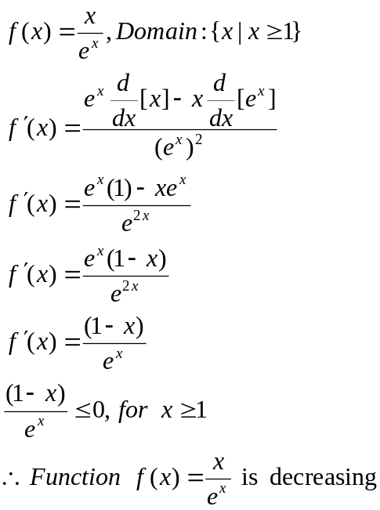

Bounded Sequences
For 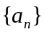
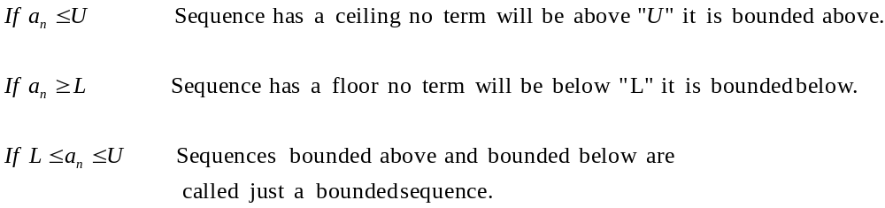
Monotonic Bounded sequences always converge

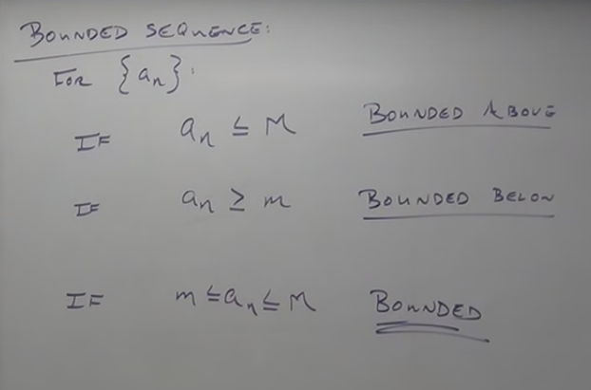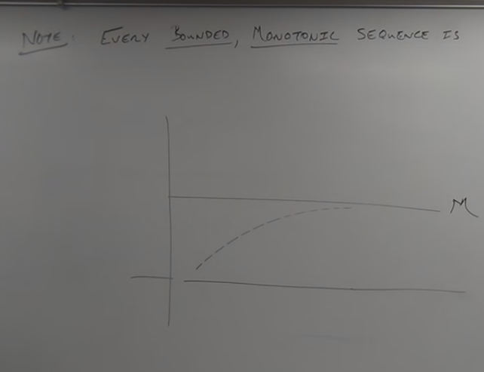
Example
Show 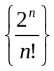 is convergent.
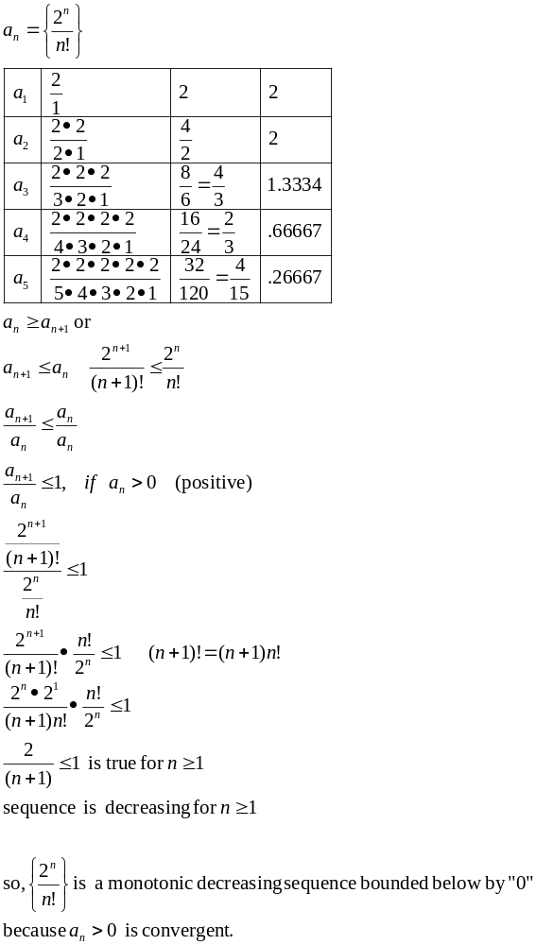

NOTE
